2017-2018 Annual Work Report
Silk Road Agricultural Education and Research Innovation Alliance
(July 2017 to October 2018)
On November 5, 2016, initiated by Northwest A&F University, 59 agricultural universities and institutes from 12 countries along the Silk Road, established the Silk Road Agricultural Education and Research Innovation Alliance in Yangling. After development and improvement over the past year, the Alliance has recruited 72 members from 14 countries and achieved remarkable results in the operation and management. The following is the annual work of the Alliance from July 2017 to June 2018 by the Secretariat:
I Progress of the Alliance
- Cooperation platform establishment and mechanism innovation
- Construction of the Silk Road Agricultural Education and Research Innovation Alliance
After the establishment of the Alliance, it has carried out a series of fruitful work in personnel training, scientific research, technology promotion, humanities exchange and think tank construction and made positive contributions to promoting scientific and technological cooperation in agricultural education along the Silk Road.
From July 3rd to July 5th, 2018, the Alliance Secretariat hosted the 2nd Silk Road Agricultural Education and Research Innovation Forum and the 2nd Alliance Council in Astana, Kazakhstan. More than 150 agricultural and forestry scientists from 45 science and education units from 7 countries attended the meeting to discuss the deepening cooperation between the Silk Road Agricultural Education and Research Innovation Alliance and how to better serve the “Belt and Road” strategy and benefit the countries and people along the route. The forum also attracted 13 new members to join the Alliance, including the first batch of business units. The addition of business units not only injected fresh blood into the Alliance, but also provided a way and platform for agricultural science and technology achievements to be transformed into productivity as soon as possible.
From July 2nd to July 5th, 2018, the third Forum and Alliance Council, hosted by the Alliance Secretariat and Serbian Institute of Land and Crop Vegetables, was held in Novi Sad, Serbia. Nearly 120 representatives of 35 units from 7 countries including China, Serbia, Russia, Kazakhstan, Poland, Jordan and the Netherlands participated in the seminar and jointly conducted extensive discussions on the “Agricultural Education and Research Innovation”. In addition, this forum discussed the application for membership of four units. So far, 76 units from 14 countries have participated in the Alliance.
Since the establishment of the Alliance in the past three years, it has achieved fruitful results and expanded from the agricultural field to resources, environment and food processing; from focusing on applied research and technology promotion to basic and frontier research; from students cultivation and other educational exchanges to the expansion of cultural exchange. At the same time, the Alliance has made important progress in the construction of international cooperation platforms, the construction of think tanks and the innovation of cooperation mechanism, etc.
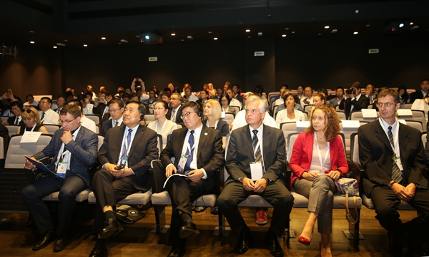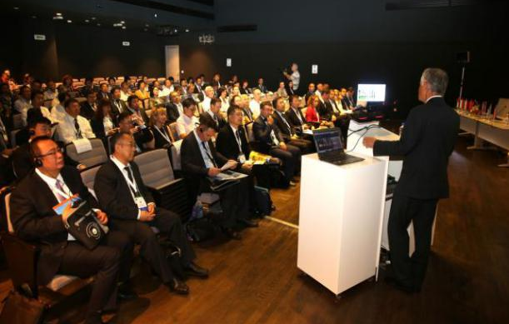
2018 Silk Road Agricultural Education and Research Innovation
Newly Joined Units Signed Yangling Declaration
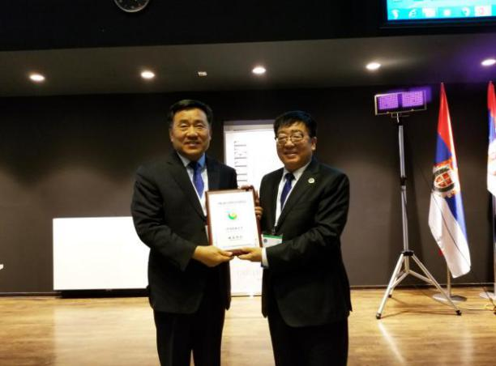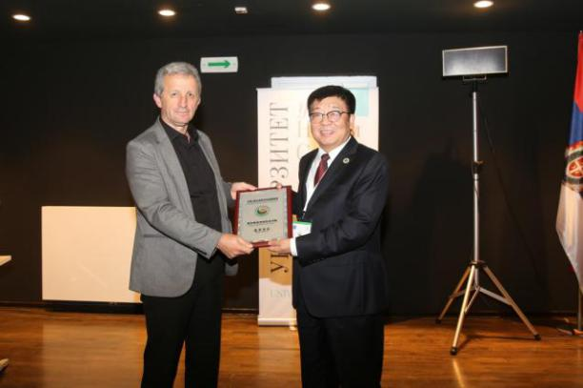
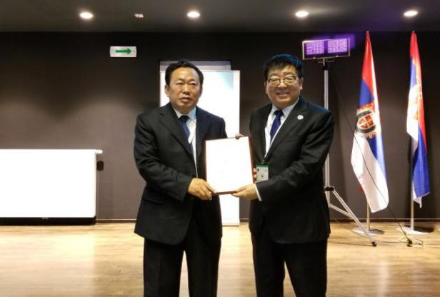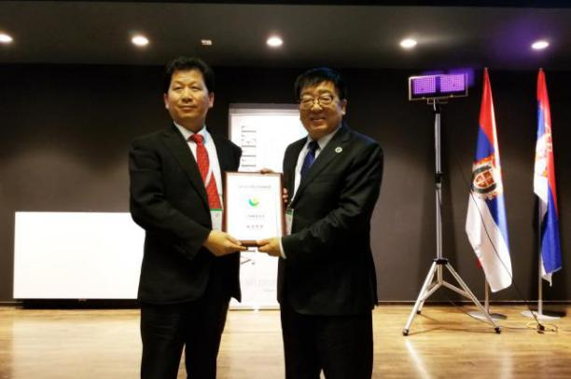
Alliance Secretary-General Wu Pute awarded the new Alliance unit
- Established three sub-alliances to strengthen the construction of the alliance
---Established the Sino-Russian Agricultural Education and Technology Innovation Alliance
Under the guidance of the Department of International Cooperation and Exchanges of the Ministry of Education, in July 2017, Northwest A&F University and Omsk State Agrarian University of Russia jointly initiated the establishment of Sino-Russian Agricultural Education and Research Innovation Alliance in Astana. 16 Chinese and Russian universities participated in this professional platform for refining and deepening the all-round agricultural science, technology education and humanities exchanges between China and Russia.
In October 2017, the Ministry of Education incorporated Sino-Russian Agricultural Education and Research Innovation Alliance into the Sino-Russian People-to-People Exchange Program to promote the close cooperation between agricultural universities and scientific research institutions of China and Russia in personnel training, scientific research, technology extension, humanities exchanges, policy research and to enhance cultural exchanges by establishing cultural centers, organizing cultural festivals, academic visits and summer or winter camps and setting up Confucius Institutes or Confucius Classroom in Russia. In addition, the alliance will further explore the new mechanisms of scientific and technological cooperation in agricultural education between China and Russia, and strive to make greater contributions to the sustainable development of China's agricultural education and the enhancement of international competitiveness.
---Established the Silk Road Bio-Health Agricultural Industry Alliance
In July 2017, NWAFU and the Pakistan Science Foundation jointly organized the “Belt and Road” International Symposium on Biological Health Agriculture. At the meeting, NWAFU initiated the establishment of the Silk Road Bio-Health Agricultural Industry Alliance together with more than 50 domestic institutions and enterprises and released the Yangling Declaration of the Silk Road Bio-Healthy Agricultural Industry Alliance. The Alliance aims to build a bio-healthy agricultural platform, upgrade the healthy agriculture industry, support and guide social capital, modern production factors and business models to the bio-healthy agriculture industry, promote the integration and efficient use of resources, increase the income of farmers and promote the competitiveness on the rural and agricultural industries.
---Established the “Silk-Road Viticulture and Enology Alliance” and Silk Road Wine Research Institute
On April 21, 2018, launched by the NWAFU college of Viticulture and Enology, 33 institutions from the United States, Kazakhstan, Italy, Canada, Australia, New Zealand, France and other countries set up Silk-Road Viticulture and Enology Alliance & Silk Road Wine Research Institute in Northwest A&F university.
The Viticulture and Enology Alliance is of great significance to further promote the wine culture of the Silk Road and strengthen the cooperation and exchanges between countries and regions along “Belt and Road” in wine science and technology and wine industry. It is hoped that the members of the Alliance will adhere to the spirit of peace, cooperation, openness tolerance, mutual learning and mutual benefit. By promoting the in-depth exchanges between China and countries and regions along the Silk Road in the fields of wine education, technology and industrial development, the wine industry will benefit more countries and people in the process of co-construction, sharing, exchange and integration.
- Build a Chinese teaching center and strengthen cooperation among countries along the “Belt & Road”
Northwest A&F University has reached a preliminary cooperation intention with the relevant universities in Kazakhstan and will continue to strenghthen communication with the relevant universities and China National Office for Teaching Chinese as Foreign Language. We plan to apply for setting up a new major---International Education for teaching Chinese as a foreign language, actively prepare for building a Chinese teaching center and strengthen cooperation among countries along the “Belt & Road”.
- Carried out exchanges between students
From July 2nd to 5th, 2017, the second session of the Alliance Council and Academic Forum was held in Astana. Students from Northwest A&F University together with students from S.Seifullin Kazakh Agro Technical University and the Kazakhstan National Symphony Orchestra presented a wonderful performance. From June 15th to 29th, 2018, the member of the Alliance - Kazakhstan National Agricultural University held a two-week summer camp in Almaty. This summer camp was mainly held for master students and young teachers of Alliance members. Our university organized 18 teachers and students from Shanxi Agricultural University and Shandong Agricultural University to participate in this summer camp. Through the two-week exchange and study, teachers and students from different professional directions and different countries have improved their professional cultivation and greatly promoted the friendly cooperation between the countries along the “Belt and Road”.
Ⅱ. Sci-tech extension promotion and overseas demonstration park construction
- Strengthened the construction of overseas demonstration parks
In order to implement the Alliance strategy agreement, the secretariat reached a joint research and education agreement with S.Seifullin Kazakh Agro Technical University and Kazakh National Agrarian University separately at the end of 2016 to jointly build the Sino-Kazakh agricultural science and technology demonstration park at the sites of the two universities. In July 2017, under the witness of Chinese Agriculture Minister Han Changfu and Kazakhstan's First Deputy Prime Minister, the co-construction signing ceremony and opening ceremony of the demonstration park were officially held. Since the Conference of Astana in 2017, spring planting crops and autumn planting crops have been successfully introduced in two demonstration parks in Kazakhstan by the Alliance members.
On September 8th, the “China-Kyrgyzstan Modern Agriculture Demonstration Zone” jointly established by NWAFU and Kyrgyzstan Pastoral Animal Husbandry Co., Ltd. and Yangling Leda Biotechnology Co., Ltd. was officially inaugurated in Moscow, Chuy State, Kyrgyzstan. NWAFU Party Secretary Li Xingwang attended the unveiling ceremony. “China-Kyrgyzstan Modern Agriculture Demonstration Zone” is the “Belt and Road” agricultural science and technology education key cooperation project of NWAFU. It is located in the Moscow area of Chuy State in the suburb of Bishkek, the capital of Kyrgyzstan, which has received strong support from the Ministry of Agriculture and the local government of China and Kyrgyzstan. In 2018, the demonstration area of the first phase of the demonstration zone is 10 hectares, which respectively present the 7 new apple varieties introduced by NWAFU, 1 apple high-efficiency cultivation model and 42 new corn varieties provided by the members of the Silk Road Agricultural Education Science and Technology Innovation Alliance. Under scientific planning and meticulous management of the joint construction from the three parties, the demonstration crops performed well and received high attention and unanimous approval from the local government, agricultural enterprises and surrounding farmers.
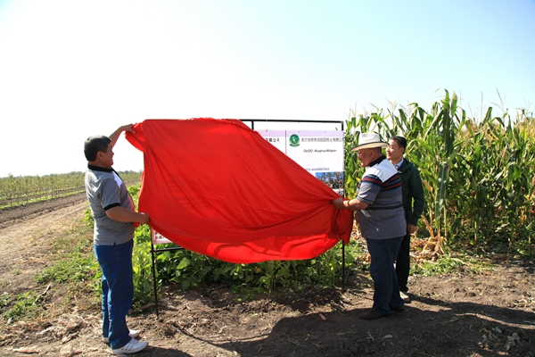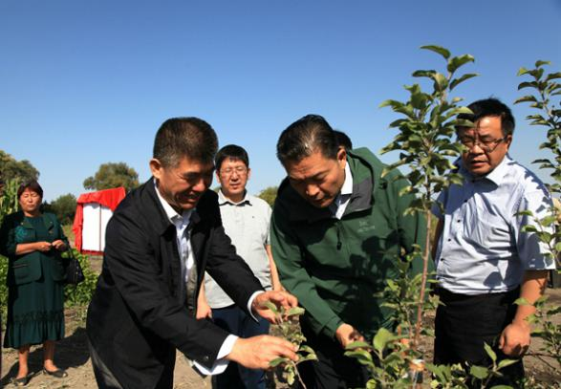
NWAFU Party Secretary Li Xingwang, the Director of the Kyrgyz National Project Office, Bayem Beit and the Director of the Plantation and Inspection and Quarantine Bureau, Kubat, jointly unveiled the demonstration zone.
- Strengthened the support of technological equipment and enhanced the research techniques in agricultural demonstration parks
Since the launch of the Sino-Kazakh agricultural science and technology demonstration park project with Kazakhstan National Agricultural University, S.Seifullin Kazakh Agro Technical University and the National University of North Kazakhstan, the scientific and educational personnel of the two sides have been engaged in scientific research, academic exchanges and personnel training on the principle of mutual benefit, which has effectively promoted the friendly cooperation between our university and the three universities in Kazakhstan and the two countries. In order to further improve the future research work and the research techniques of the demonstration park, with the support of the Ministry of Science and Technology of China in the project of scientific and technological assistance to developing countries – “the construction of Sino-Kazakh agricultural science and technology demonstration park”, NWAFU has purchased agricultural machinery and equipment such as tractors, planters, turning ploughs and rotary tillers that are urgently needed for field operations for the Astana Park and the North Kazakhstan State Park of the Sino-Kazakh agricultural science and technology demonstration park.
3. Enhanced cooperation between universities and enterprises and exploited advantages of all partners
As one of the first food enterprises “going global” , Xi'an Aiju Grain and Oil Industry Group Co. Ltd has built the largest agricultural product processing park in north Kazakhstan province, 150,000-mu grain and oil contract farming base, and an oil processing plant with a daily processing capacity of 1,000 tons. In order to fully utilize the advantages of both parties and realize win-win cooperation, the Alliance secretariat signed a cooperation agreement with Xi'an Aiju Grain and Oil Industry Group Co. Ltd in September 2017, on building an experimental agricultural demonstration base in north Kazakhstan province, jointly pursuing technological breakthroughs and expanding personnel training. In September 2018, the “Grain and Oil Industry (Northern Kazakhstan) Science and Technology Innovation Base” jointly established by the two sides was unveiled in North Kazakhstan.
NWAFU and Shandong Xisen Potato Industry Group have carried out a variety joint trial in Astana and Almaty Demonstration Parks in Kazakhstan. Through observation and research, it was found that the local climate has a high demand for drought resistance of crops. The Ningshu and Ganshu series introduced from Ningxia and Gansu regions in China have shown high yield potential and cold resistance, which can be promoted in a large-scale.
NWAFU is under negotiation with Golden Valley Agricultural Commonwealth Co., Ltd., a Chinese-funded enterprise in Tajikistan. NWAFU has reached cooperation intentions on jointly carrying out the introduction and cultivation of new superior varieties of grain and cotton, standardized cultivation mode and supporting technology research and cultivation of technical personnel in grain and cotton production.
III. Enhanced the cultivation of agricultural talents
Since 2007, NWAFU has enrolled 2,144 international students, including 530 degree candidates and 1614 non-degree candidates. Among the 337 foreign students currently studying on NWAFU campus, 53 come from Central Asia (44 Kazakhstan students) accounted for 16% of the total admission, mainly studying in the College of Agronomy, College of Food Science and Engineering, College of Economics and Management and College of Veterinary Medicine for Master’s or Doctor’s degree.
In recent years, NWAFU has set up high-quality international training courses in the agricultural fields around the world, especially in Central Asia, to cultivate international talents needed for agricultural cooperation and trained more than 120 agricultural technology talents in Central Asia. In addition, NWAFU sent 52 people to Kazakhstan, Kyrgyzstan, Tajikistan and other countries for technical assistance and cooperation. In 2017, NWAFU was successfully approved by the Ministry of Agriculture as one of the first batch of support and talent training bases for agricultural technology foreign cooperation and held successively “Kazakhstan Livestock Development Training Course”, “Asian National Facilities Agriculture and Sand Industry Development Training Course”, “Kazakhstan Agriculture and Animal Husbandry Special Training Course”, “Kazakhstan Grain, Oil and Starch Researching and Processing Training Course” and“‘Belt and Road’ and Training Courses on Soil and Water Conservation and Ecological Restoration in Developing Countries”. A training course on Grain and Oil Processing and International Trade of the Silk Road Agricultural Education and Research Innovation Alliance was held for agricultural enterprises taking their place on the International market.
4. Established cross-nation research centers to strengthen think tank construction
In 2017, A&F established three research centers in Africa, namely, the African Research Center, the Kazakhstan Research Center, and the China-Russia Agricultural Science and Technology Development Policy Research Center. Among them, the Kazakhstan Research Center and the African Research Center have been registered into 2017 national and regional research centers of the Ministry of Education.
Central Asia and Africa are important targets for China's foreign investment in agriculture, trade, technology and productivity. Establishing Kazakhstan and African cross-nation research centers will help enrich the detailed and comprehensive understanding of relevant countries and the situation and conditions for the development of scientific research cooperation.
The Kazakhstan research center published “A Comparative Study of Agriculture between China and Kazakhstan”. As a major country in Central Asia and a leading economic power, Kazakhstan is also the first stop of the “Belt and Road”， extending to the west, which plays an very important role. From the perspective of agricultural comparison between China and Kazakhstan, this book introduces and compares in detail the geographical environment, the position of agriculture in the national economy, the features of agricultural resources, the agricultural production structure and changes, agricultural policies, international cooperation in agriculture, international competitiveness of agricultural products, the competitiveness and complementarity of agricultural products trade, trade potential of agricultural products and prospects for agricultural cooperation between the two countries. The publication of this work provides a theoretical basis for agricultural cooperation with Kazakhstan and even Central Asia. It is also of great significance for China to have a thorough understanding of Kazakhstan's agricultural development, to develop trade in agricultural products and to carry out agricultural international cooperation between the two countries on a larger scale.
China-Russia Agricultural Science and Technology Development Policy Research Center has completed the directory report on “Russian Scientific and Technological Organization Directories” and the policy report of “Research Report on Russian Scientific and Technological System” and continues to promote other related research work. The “Russian Scientific and Technological Organization Directories” compiled by the Center covers a total of 157 Russian scientific and technological organizations (200 pages, about 125,000 words). It comprehensively summarizes the general information, organization and main activities of Russian scientific and technological organizations. The “Report on the Development Policy of Sino-Russian Scientific and Technological Cooperation” has 15,000 words. It analyzed the current situation of Russian scientific and technological system and the future potential of Sino-Russian scientific and technological cooperation in detail and gives policy recommendations on the problems existing in Sino-Russian scientific and technological cooperation.
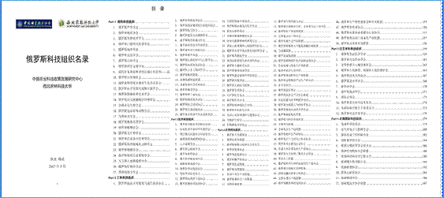
Manuscript of “Russian Scientific and Technological Organization Directories”
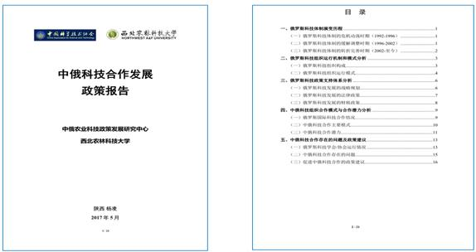
Manuscript of “Report on the Development Policy of Sino-Russian Scientific and Technological Cooperation”
II Working plan of next phase
NWAFU will continue to pursue solid and practical progress of the Alliance, hold regular Silk Road Agricultural Education and Research Innovation Alliance Forum and actively explore on establishing education and scientific institutions, innovation platforms, technology promotion bases and Silk Road culture exchange centers. A&F will organize works in the following three aspects:
- To innovate and extend advanced agri-technology by exerting the comparative advantages of Chinese agricultural science and technology
Alliance Secretariat will further strengthen the promotion of agricultural technology, build about 20 agricultural science and technology demonstration and promotion bases, 10 international joint laboratories and 10 technology transfer platforms in countries along the Silk Road to demonstrate and popularize new crop varieties and processing standards for agricultural products in China, focusing on the agricultural development needs of countries and regions along the Silk Road, giving play to the advantages of member units and promoting the transformation of scientific research achievements and technology popularization.
- To further improve national and regional research and build characteristic high-end think tanks
Alliance Secretariat will further strengthen the construction of the South-South Agricultural Cooperation College of China, build internationally leading new think tank research institutions integrating education, research and industries and linking government, enterprises and social organizations through the construction of Sino-Russian, China-Kazakhstan, and China-Africa Research Centers. NWAFU will release periodically the Report on Silk Road Agricultural Education Science and Technology Development to offer political, economic, and cultural advisory service to government policy-making, business investment, and production capacity cooperation.
- To further undertake personnel training and intellectual service
NWAFU will strengthen the construction of Silk Road Agricultural Education and Research Innovation training bases to provide professional training for the agricultural management personnel, technical backbones and industrialization leaders and further promote economic cooperation and cultural exchanges along the Silk Road.
- Expand cultural exchanges and enhance people's friendship
NWAFU will expand multi-channel communication platforms, build diversified and distinctive sub-alliances and other forms of communication platforms under the framework of the Alliance, encourage member units to organize various activities such as knowledge contests, cultural experience, sports competitions and culture and art festivals and conduct collaborative research on the culture communication along the Silk Road to promote the cultural development along the Silk Road.

